Homework 9

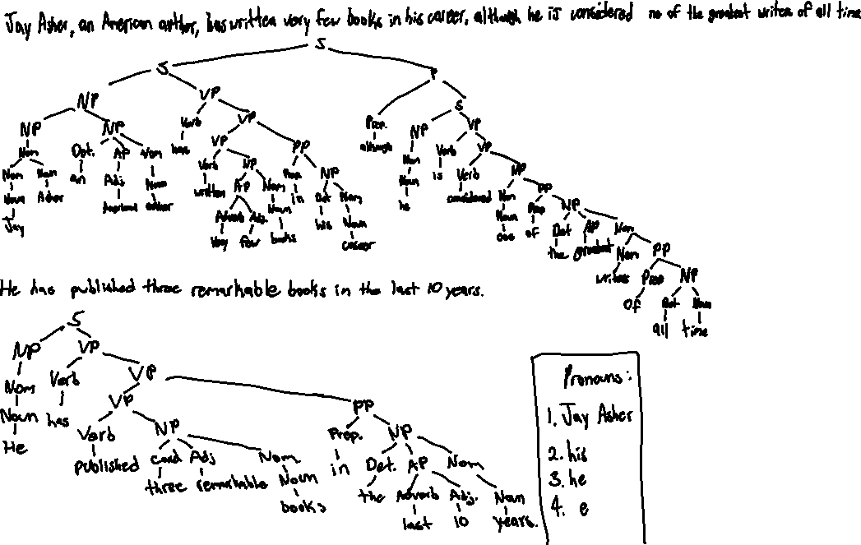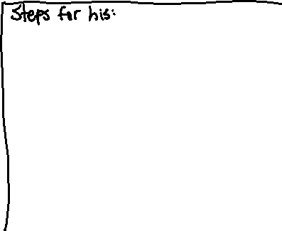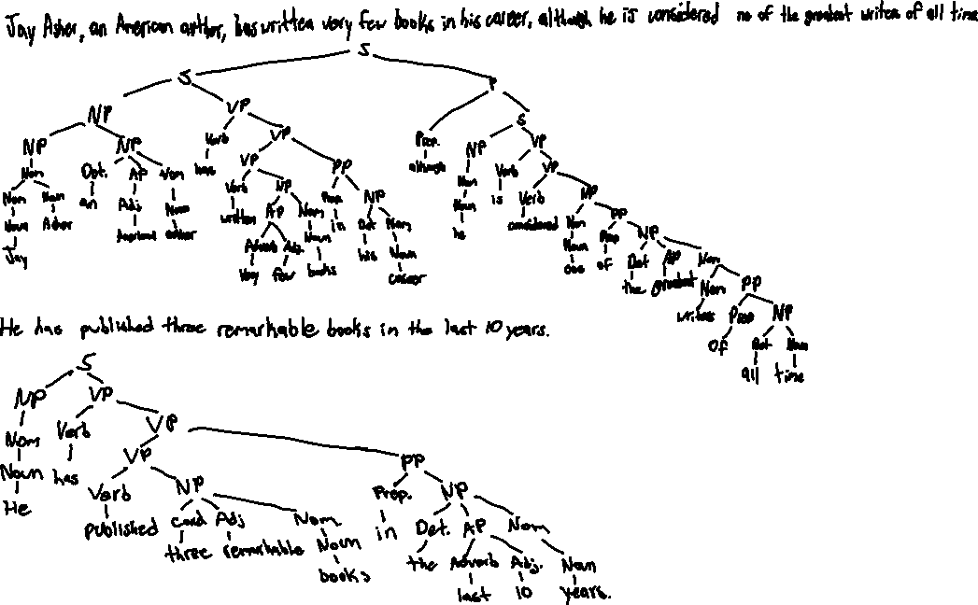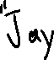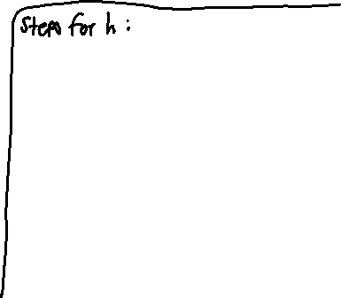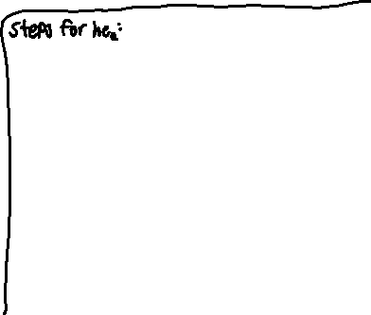

2a. Correct Referent: “the thin, hard, black-burnished pottery” Incorrect Referent: “The site”

2b. Correct Referent: “the cave filling” Incorrect Referent: “The geological age”

2c. Correct Referent: “the recipients” Incorrect Referent: “bronze vessels”

2d. Correct Referent: “men and animals” Incorrect Referent: “stony rubble”

3.



[It was New York City’s first new subway station in a quarter century,]1 [and officials and riders marked the opening of the Hudson Yards station in September with much fanfare.]2 [But less than six months later, riders began to notice water leaking from above.]3 [At a meeting last week, board members demanded to know]4 [how the Metropolitan Transportation Authority could have spent $2.4 billion on a project that leaks.]5 [In fact, leaks had plagued the station on the Far West Side of Manhattan for years while it was under construction.]6 [As the transit agency investigates what exactly went wrong,]7 [documents from a continuing legal dispute among the site’s contractors reveal early concerns about how the waterproofing system was built and the type of concrete that was used.]8

Nuclei: Segments 1, 4, 5, 7

Satellites: Segments 2, 3, 6, 8

(Goes into signifies the arrow (Ex: 2 goes into 1 == 2 -> 1))

Title: New York City’s first new subway station

1-2 Relationship: Elaboration (2 goes into 1)

3-4 Relationship: Background (3 goes into 4)

5-6 Relationship: Elaboration (6 goes into 5)

7-8 Relationship: Elaboration (8 goes into 7)

1-8 Relationship: Elaboration (Goes into 1-2)

3-8 Relationship: Elaboration (Goes into 3-4)

5-8 Relationship: Elaboration (Goes into 5-6)